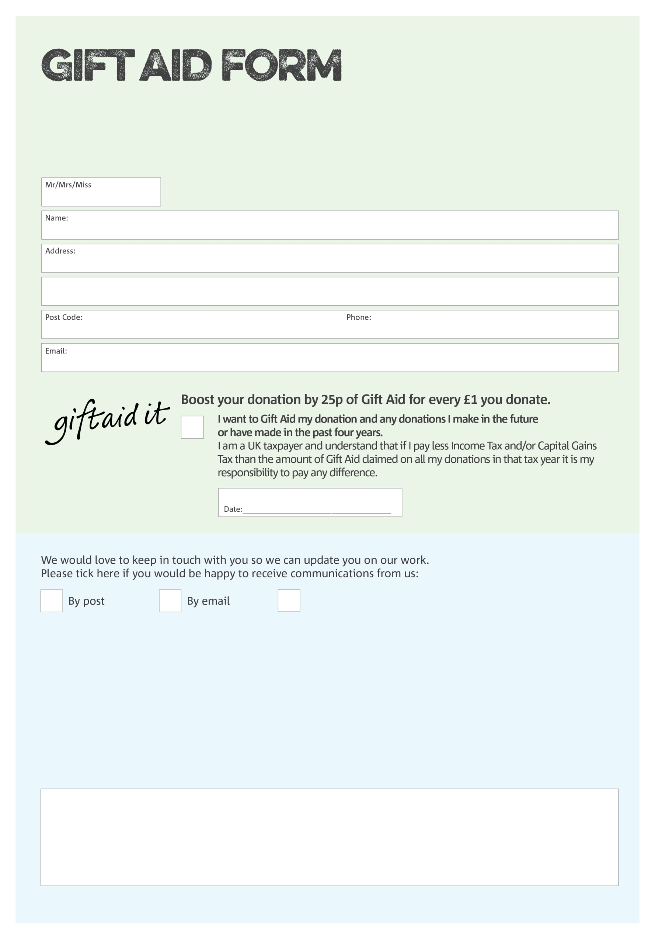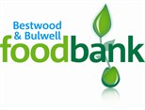

By filling in this form Bestwood & Bulwell Foodbank will receive an extra 25p for every £1 you give at no extra cost to you. Thank you!

We would love to know why you have chosen to donate to Bestwood & Bulwell Foodbank. If you would like to share your motivation let us know below:

**Data protection**

Bestwood & Bulwell Foodbank is committed to protecting your privacy and will process your personal data in accordance with the Data Protection Act 1998. Bestwood & Bulwell Foodbank collects information to keep in touch with you and supply you with information relating to our work. Bestwood & Bulwell Foodbank will never sell or pass your details to anyone who isn’t directly working on our behalf.

You can change your preferences any time by contacting us on 0115 9751825 or emailing us at

info@bestwoodbulwell.foodbank.org.uk

I do not wish to receive future communications from Bestwood & Bulwell Foodbank

Charity Number XXXXXX. Registered in XXXXXXX